The process of making [to be named]

A month into making this game I decided to record the process of it's development as it unfolds.

The technologies I decided to use are mostly TypeScript with some occasional jQuery here and there, done in Angular.

# Why Angular?

Because it was on one of my last exams and I was comfortable with it. I didn't really know exactly what benefits I would have from using it, but I did it anyway. I knew it was good for Single Page Applications and that was enough for me.

Later on I found it extremely useful for having typescript and abilities to import and export other script files. Since I wasn't using any gaming framework and had to make my own from scratch, I knew I had to enforce some OOP rules if I wanted to keep my sanity.

# Why not just use an already built game engine?

**The answer is simple.**

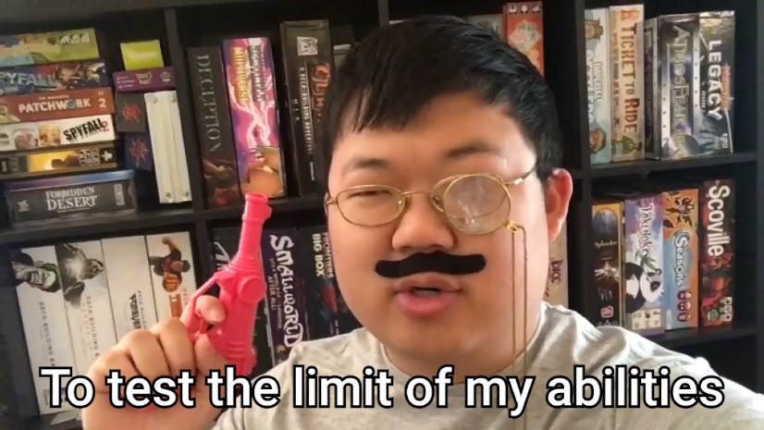

The idea

For starters, I knew I would be making an html game without any fantsy-pants 3D WebGL graphics or pre-built engines.

*I had to think of something simple.* I decided to use canvas.

The next thing was to decide the genre of the game.